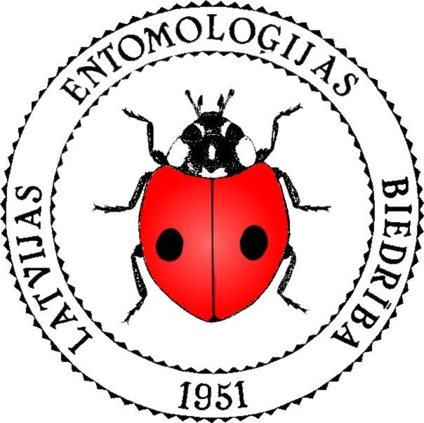 | THE ENTOMOLOGICAL  SOCIETY  OF LATVIA
Registration number 40008007914
O.Vācieša iela 4, Rīga, LV-1004, Latvia
Phone: +371 29297840; E-mail: leb@entomologi.lv
WEB: http://www.entomologi.lv/

Application

Please admit me to the Entomological Society of Latvia. I have familirized myself with the statutes of Entomological Society of Latvia and I undertake to follow them. I pledge to uphold the honor of being a member of Entomological Society of Latvia!

I provide the following information about myself:
First name
Last name
Personal No.
Address
Phone number
E-mail
WEB:
My specialization in entomology (invertebrate zoology)

I want to participate in following activities of the Entomological Society of Latvia:
Meetings |  |  | Public education
Field trips |  |  | Creating public image of the Society
Scientific expeditions |  |  | Making international contacts
Organizing daily work |  |  | Participating in working group about forest issues
Maintaining the Society website |  |  | Participating in working group about nature protection
Preparing of projects |  |  | Participating in working group about insect observations
Publishing work |  |  | Other activities:

I agree that my personal data, in accordance with Article 28, Part 2 of the Law on Associations and Foundations of the Republic of Latvia, will be recorded in the register of members of the Latvian Entomological Society. I agree that the rest of the information provided by me in this application is used by the Latvian Entomological Society for communication with me.

___________________ uzņemts (-a) Latvijas Entomoloģijas biedrībā ar valdes lēmumu Nr. ______ ____. gada ___. __________________. Jaunuzņemtais biedrs (-e) ir informēta par šo valdes lēmumu vēstulē Nr. _________.

Valdes priekšsēdētāja paraksts:

